

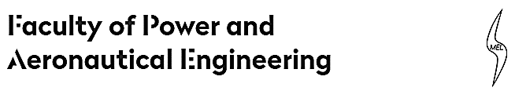

Institute of Heat Engineering

**„Simplified simulation of bypass engine in Cantera environment.”**

Tomasz Łobodziec

Field of study: Aerospace Engineering

Specialization: Aircraft Engines

Warsaw, 2019

This is a half-semester Cantera project made for Computer Methods in Combustion subject in Warsaw University of Technology in Faculty of Power and Aeronautical Engineering. This project intends to simulate a gas flow and combustion in turbofan engine using Cantera and Python environment.

**Table of Contents**

**1. Introduction. 2**

**1.1. Cantera 2**

**1.2. Turbofan engine. 2**

**2. Review of the literature. 3**

**2.1. Tutorials and examples shown on cantera.org 3**

**2.2. Other internet pages with help on python programming. 3**

**2.3. Thermodynamic equations used in “Turbine Engine” course in Institute of Heat Engineering. 3**

**3. Model description. 3**

**3.1. Data set. 4**

**4. Results review. 5**

**4.1. Variable f (fuel ratio) 5**

**4.2. Variable M (Mach number). 6**

**4.3. Variable Mach number and Altitude. 7**

**4.4. Example of the exhaust gas. 8**

**5. Summary. 9**

# Introduction.

## **Cantera**

Cantera is an open-source suite of tools for problems involving chemical kinetics, thermodynamics, and transport processes. Cantera automates the chemical kinetic, thermodynamic, and transport calculations so that the users can efficiently incorporate detailed chemical thermo-kinetics and transport models into their calculations. Cantera utilizes object-oriented concepts for robust yet flexible phase models, and algorithms are generalized so that users can explore different phase models with minimal changes to their overall code.In this project, Cantera is used to model a simple flow through a bypass jet engine. Fuel used in this model is $C_{3}H_{8}$. The reason for that is because Cantera doesn’t model the combustion of a liquid fuel. That is why in this project engine fuel is in a gas state.

## **Turbofan engine.**

The turbofan is a type of [airbreathing jet engine](https://en.wikipedia.org/wiki/Airbreathing_jet_engine) that is widely used in [aircraft propulsion](https://en.wikipedia.org/wiki/Aircraft_engine). The word "turbofan" is a [portmanteau](https://en.wikipedia.org/wiki/Portmanteau) of "turbine" and "fan": the turbo portion refers to a [gas turbine engine](https://en.wikipedia.org/wiki/Gas_turbine_engine) which achieves [mechanical energy](https://en.wikipedia.org/wiki/Mechanical_energy) from combustion, and the fan, a [ducted fan](https://en.wikipedia.org/wiki/Ducted_fan) that uses the mechanical energy from the gas turbine to accelerate air rearwards. Thus, whereas all the air taken in by a [turbojet](https://en.wikipedia.org/wiki/Turbojet) passes through the turbine (through the [combustion chamber](https://en.wikipedia.org/wiki/Combustion_chamber)), in a turbofan some of that air bypasses the turbine. A turbofan thus can be thought of as a turbojet being used to drive a ducted fan, with both of these contributing to the [thrust](https://en.wikipedia.org/wiki/Thrust).

The ratio of the mass-flow of air bypassing the engine core divided by the mass-flow of air passing through the core is referred to as the [bypass ratio](https://en.wikipedia.org/wiki/Bypass_ratio). The engine produces thrust through a combination of these two portions working together; engines that use more [jet thrust](https://en.wikipedia.org/wiki/Propelling_nozzle) relative to fan thrust are known as low-bypass turbofans, conversely those that have considerably more fan thrust than jet thrust are known as high-bypass. Most commercial aviation jet engines in use today are of the high-bypass type, and most modern military fighter engines are low-bypass. [Afterburners](https://en.wikipedia.org/wiki/Afterburner) are not used on high-bypass turbofan engines but may be used on either low-bypass turbofan or [turbojet](https://en.wikipedia.org/wiki/Turbojet) engines.

Modern turbofans have either a large single-stage fan or a smaller fan with several stages. An early configuration combined a low-pressure turbine and fan in a single rear-mounted unit.

# Review of the literature.

This project is based on knowledge from three main origins:

## **Tutorials and examples shown on cantera.org**

* <https://cantera.org/tutorials/python-tutorial.html>
* <https://cantera.org/examples/python/reactors/mix1.py.html>
* <https://cantera.org/examples/python/reactors/reactor1.py.html>
* <https://cantera.org/documentation/docs-2.4/sphinx/html/cython/thermo.html>

## **Other internet pages with help on python programming.**

* <https://matplotlib.org/>
* <https://docs.scipy.org/doc/numpy-1.15.0/user/basics.creation.html>
* <http://cs231n.github.io/python-numpy-tutorial/>
* <https://treyhunner.com/2016/04/how-to-loop-with-indexes-in-python/>

## **Thermodynamic equations used in “Turbine Engine” course in Institute of Heat Engineering.**

# Model description.

The program uses input data to calculate output propeties of a stream of gas and the engine propeties like temperature before turbine, thrust, exhaust velocity and efficiencies. Input data contains information about atmosphere in which the engine is located, the Mach number and the propeties of the engine itself. After that is the “core”.

In the beginning the stream of gas is created using Cantera enviroment. This gas goes through fan, gets splitted in two and goes through compressor. The gas properties are calculated based on thermodynamics equations. Next the stream of fuel is created. Using Cantera reactor two streams are mixed together. Program assumes that the two stream are fully mixed before combustion begins. And combustion is also modelled with different Cantera reactor. Before going through turbine the combustion advances to steady state. Transition through turbine is modelled with thermodynamic equations. Before nozzle the is often found in bypass engines mixer. This mixes two streams that were splitted before compressor and uses the same reactor used in mixing fuel with air. This uniform gas goes through nozzle and its final properties are calculated using approximated nozzle equations. Exhaust gas by using Cantera gives us every data to calculate efficiencies and properties of the engine.

This “core” is run several times in the program. It is to gather data from multiple cases and use this data to find optimal parameters and to make plots showing how engine operates in different situations.

## **Data set.**

One set of input data is used in all simulations. Three variables have been chosen to show the results of this program.

Input data contains:

* Temperature at sea level = 15 $℃$
* Intake compress = 0,98
* Intake Diameter = 0,5 m
* Stationary mass flow rate = 50 kg/s
* Bypass ratio = 1,5
* Fan compress = 3,5
* Fan efficiency = 0,97
* Compressor compress = 15
* Compressor efficiency = 0,92
* $ν_{c}$ =0,02
* Turbine mechanical efficiency = 0,99
* Turbine thermal efficiency = 0,95
* Nozzle $∅_{n}$ =0,95
* Combustion Chamber compress = 0,98
* Fuel temperature = 15 $℃$
* Air = O2:0.21, N2:0.78, AR:0.01
* Fuel = C3H8

Variables:

$f∈(0;0,04)$

$H∈(0 m;11000 m)$

$M∈(0;1)$

# Results review.

## **Variable f (fuel ratio)**

Mach number = 0,5 (constant)

Altitude = 11000m (constant)

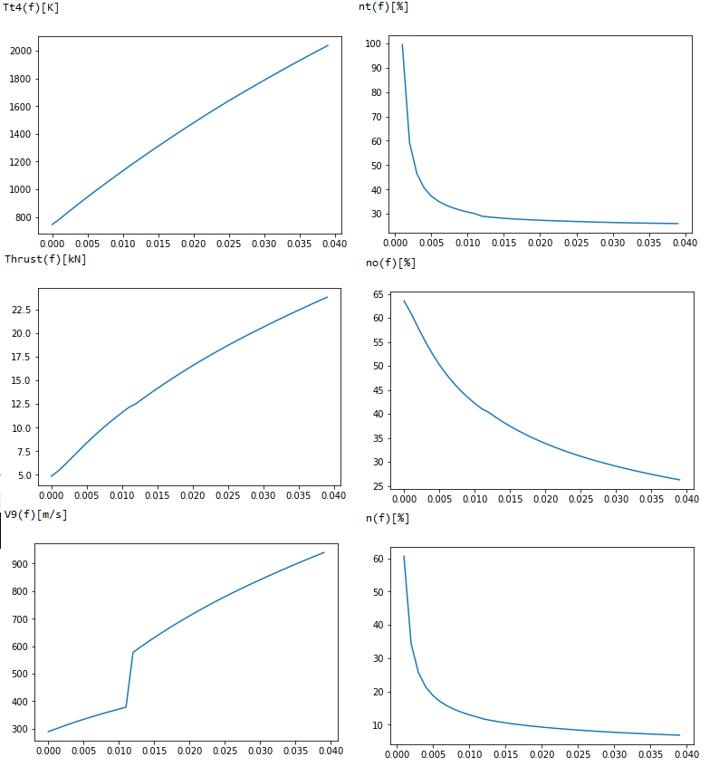

* Tt4 – Temperature before turbine in Kelvin
* Thrust in kN
* V9 – Exhaust Velocity
* nt – Thermal efficiency of the engine in %
* no – Propulsive efficiency of the engine in %
* n – Overall efficiency of the engine in %

## **Variable M (Mach number).**

f=0,02 (constant)

Altitude = 11000m (constant)

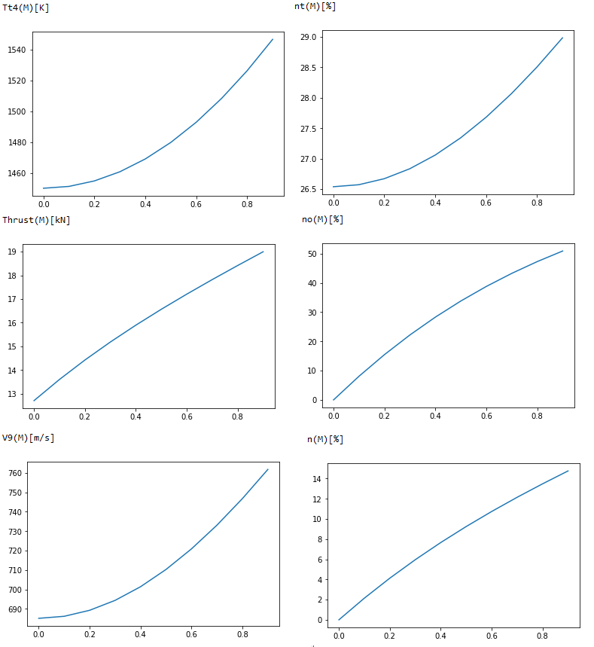

* Tt4 – Temperature before turbine in Kelvin
* Thrust in kN
* V9 – Exhaust Velocity
* nt – Thermal efficiency of the engine in %
* no – Propulsive efficiency of the engine in %
* n – Overall efficiency of the engine in %

## **Variable Mach number and Altitude.**

f=0,02 (constant)

H=0m, 2500m, 5000m, 7500m, 9000m, 11000m

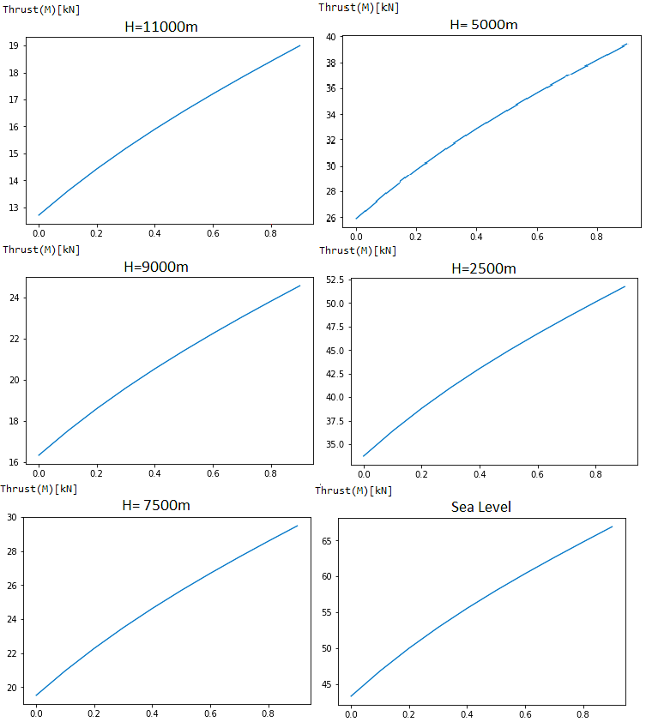

## **Example of the exhaust gas.**

f=0,02 ; M=0,5 ; H=11000m

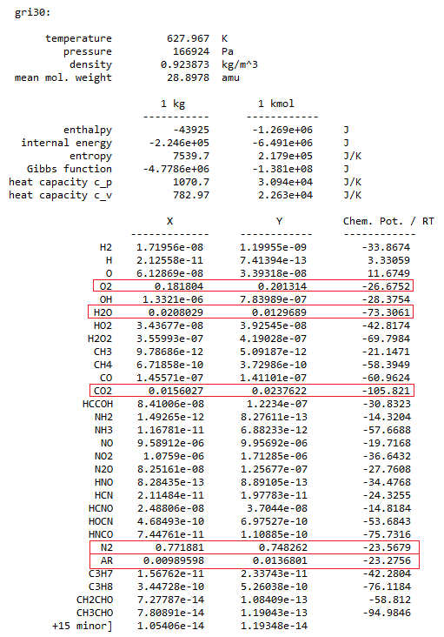

Chemical composition of this exhaust gas proves that combustion of a C3H8 takes place.

# Summary.

This simple model can give us estimated values that this engine needs to have to work properly. For example at f >=0,03 The temperatures are too high for turbine (above 1700K) and at f<=0,011 the nozzle stops working properly, the nominal compress become too high for nozzle to handle and as a result gives us results. The efficiencies are similar to what a real engine would produce.

The fact that the composition of the exhaust gas and the results being reasonable to what we should expect from a turbofan engine means that this program can be used to predict in some approximation the properties of this type jet engine. The fact that this model does not take into account all possible factors mean that this should be used only in fast and approximate calculations and not for exact and detailed information about a real turbofan engine.